Chris Jabbour

Technical Description

**Electronic Nervous System: the Motherboard**

**General description:**

Def: A *flat, printed circuit board* that holds the main parts, connectors, and other circuit boards of a computer or any electronic device.

**History and Background:**

The history of the computer motherboard dates back to the 70’s - 80’s. The etymology makeup of the word “motherboard” is mother + board with mother in the maternal sense and board referring to an electronic circuit board. The origin of the term is difficult to trace down to one source as one of the words stemming from the early days of the PC, but it appears to be a literate metaphor if we delve deeper into its connection with other parts of the computer. Computers and electronics have a set up with a mainboard (the motherboard) where one can connect smaller or secondary boards (aka daughter boards) that add features.

The earliest reference, according to the *Oxford English Dictionary*, goes back to a 1971 British journal article “*Electrical and Electronics Abstracts”* referring to one daughterboard placed vertically on a main motherboard. The first motherboards had very few actual components compared to their contemporary counterparts.

IBM created the first PC motherboard, thirty-four years ago (1981), which came with a processor and card slots where users had to plug in parts such as floppy disk drives and memory. The motherboards of today have a greater variety of built-in features. They can also affect a computer working capabilities and potential for upgrades.

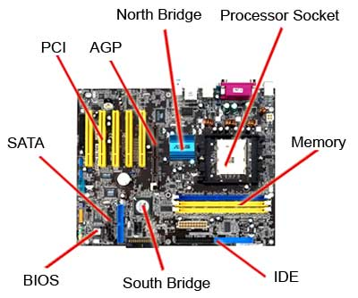

ff

**(Courtesy of HowStuffWorks.com)**

**Principle of operation:**

An electric or battery powered circuit board that allows communication between each part while holding some the essential components of a computer.

**Description & Function of parts**

There are several components pertaining to a generic motherboard. Motherboards come in many different sizes and colors like red and black with the staple of dark green as well. the general parts include:

* 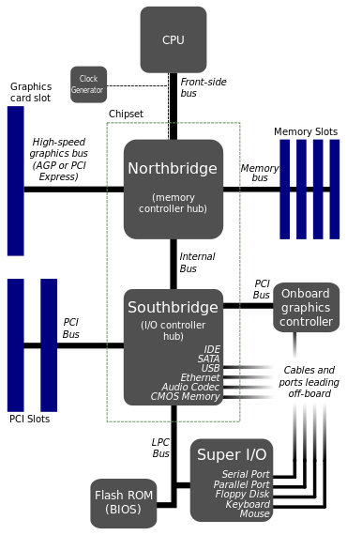**Form factor -** The shape and layout of the motherboard.

(Courtesy of simple.wikipedia.org)

* A **socket** for the **microprocessor -**
  + Connected by a Pin Grid Array (PGA).
  + Specifies and holds the Central Processing Unit (CPU).
* **Chipset –** made of the north and south bridge parts it connects the CPU with the motherboard and allows communication with other parts of the computer.
* **Basic Input/Output System** (**BIOS**) chip - controls the most basic functions of a computer.
* **Real time clock chip** – stores basic settings and system time.
* **Buses** – sets of conductors that carry data and controls signals in a computer system
* **Slots and ports** for accessories.

Examples:

* + Memory slots – Increase memory (the more RAM a module has, the faster it runs).
  + Universal Serial Bus (USB) or FireWire - connects external peripheral devices.

**Operating Description**

The motherboard holds important parts of a computer or device and connects with other different parts of the device, like the keyboard, using electric impulses traveling along conductive pathways to allow the computer to function.

**Summary**

The motherboard came from the emergence of the Personal Computer system back in the 1980’s and is wordplay on “mother” in the caretaking sense and “board” referring to its appearance as a conductive circuit board. Each motherboard has a processor and ports to allow connection and the use other accessories and parts. The basic parts have remained the same for each motherboard created and is powered by the board’s path properties with the aid of electricity. The motherboard has evolved greatly over the years to become much more advanced and able to do more in terms of functionality.